Non-spherical collapse of a buoyant bubble near a vertical rigid wall
Peng Xu¹, Bo Li^{1,2}, Zibo Ren¹, Shuhong Liu^{1,} * and Zhigang Zuo^{1, †}
¹ State Key Laboratory of Hydro Science and Engineering, and Department of Energy and Power Engineering, Tsinghua University, China
² Beijing Key Laboratory of Information Service Engineering, Beijing Union University, China
* liushuhong@mail.tsinghua.edu.cn ; † zhigang200@mail.tsinghua.edu.cn
Abstract. In practice, the pressure around the cavitation bubble is usually non-uniformly distributed and the bubble then experiences a non-spherical collapse. Here we conduct systematical experiments to study the distinct behavior of a buoyant cavitation bubble near a vertical rigid boundary. Under the combined influence of gravity and the rigid boundary, the bubble centroid migrates rapidly when the bubble completely collapses, and a micro-jet of intermediate strength penetrates the bubble in the same inclined direction subsequently. The findings of this study contribute to our understanding of the non-spherical cavitation bubble dynamics under the simultaneous influences of multiple factors.
- Introduction
Cavitation bubble will experience non-spherical collapse accompanied by deformation and micro-jet when exposed in non-uniform pressure field. Except for adjacent interfaces, the body force represented by gravity and centrifugal force can also induce non-uniform distribution of pressure in the liquid [1]. Although at atmospheric pressure, the effect of gravity is not significant for millimeter-scale cavitation bubbles, in the case of large bubbles such as underwater explosions, the gravity effect cannot be ignored [2]. Furthermore, in rotating fluid machinery, the centrifugal force plays a similar role as gravity, but of much larger magnitudes [3].
The current study focus on the non-spherical cavitation bubble dynamics under the simultaneous influences of gravity and rigid wall. We generate large laser-induced cavitation bubbles near a vertical rigid wall by lowering the background pressure in a sealed water tank, thus making the effect of gravity more pronounced. Micro-jet with intermediate intensity is observed during the rebounding stage of the bubble [4]，and whose direction and velocity change with the different combination of the two factors. By recalling the non-dimensional form of the Kelvin impulse, or the pressure anisotropy parameters, we analytically predict the jet angle, and establish the scaling law of the jet velocity.
- Experimental setup
A cavitation bubble is induced by focusing a laser pulse into degassed water in a rectangular plexiglass water chamber (280 mm×200 mm×200 mm). To highlight the effect of gravity, large bubbles with R_{max} = 2.6–6.5 mm are produced by reducing the background pressure (p_{∞, min} = 8, 476 Pa) through a vacuum pump. The desired non-dimensional standoff distance of the bubble against the vertical side wall γ = l₁/R_{max} = 2.38–13.80 is realized by adjusting the horizontal position of the convex lens (① in figure 1 (a)). As the bubble collapses, an inclined micro-jet forms at an angle θ and its direction is identified by the bubble displacement at the first rebound against the horizontal direction, as shown in figure 1 (b). The driving pressure Δp is the pressure difference between the static pressure at the level of the bubble center and the vapor pressure p_{v}.
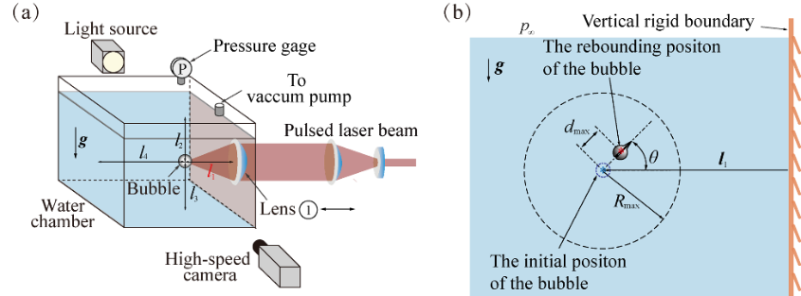
Figure 1. Schematic of the experimental setup (not to scale) and notation.
- Results and discussion
Typical results of the collapsing process of the cavitation bubble is shown in figure 2. For case (a), the sphericity of the bubbles are broken as they fold on themselves near the end of their collapses; for case (b), no obvious non-spherical deformation is observed till the bubbles reach the minimum sizes, and then the jets form almost instantly. We adopt the concept of Kelvin impulse to predict the jet direction θ, i.e. in figure 3, where and are the gravity and rigid wall induced Kelvin impulse separately [4-6].
Figure 2. Image sequences of the collapse and rebound of cavitation bubbles. The liquid jets at bubble collapses are indicated by ‘A’, and the thin vapor layers around the jets are indicated by ‘B’. The initial and collapsing positions of the bubble centers are marked with ‘*’ and ‘*’ respectively. Here, ζ_{g}=0.0048, 0.0049 and ζ_{w}=0.0213, 0.0010, for case (a-b).
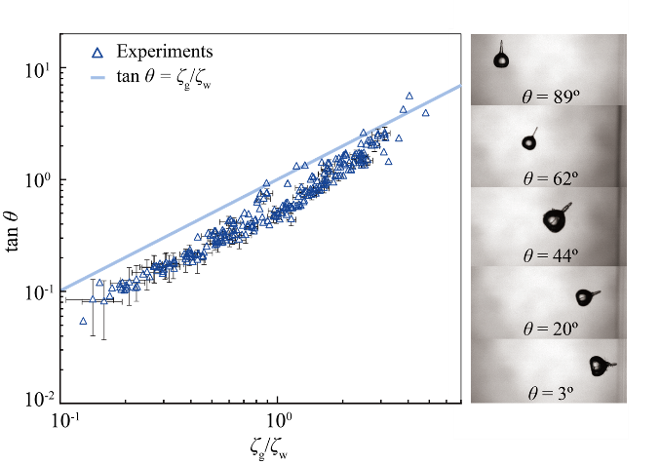
Figure 3. Experimental results of tanθ versus ζ_{g}/ζ_{w}.
In the present setup, ζ_{g}⊥ζ_{w}, so we can calculate the value of the combined impulse as ζ =(ζ_{g} ²+ζ_{w}²)^{0.5}. Figure 4(a) shows that the non-dimensional jet velocity v* =v/(Δ p/ρ)^{0.5} does not vary monotonically with ζ and the transition is around ζ =0.008. To explain this changing law, we consider the final effect of the integrated momentum, i.e. the Kelvin impulse is to push a certain volume of liquid (the jet), so we can write:
. | (1)
Here we choose a normalized displacement d*|_{t*=0-1}/d*|_{t*=0.98-1} of the bubble center during its final collapse as the characteristic length r∗, as shown in figure 4(b). Thus the scaling laws of r* and ζ can be obtained by fitting the experimental results. Further, from Eq. (1), we derive the scaling laws for v* v.s. ζ, see the lines in figure 4(a).
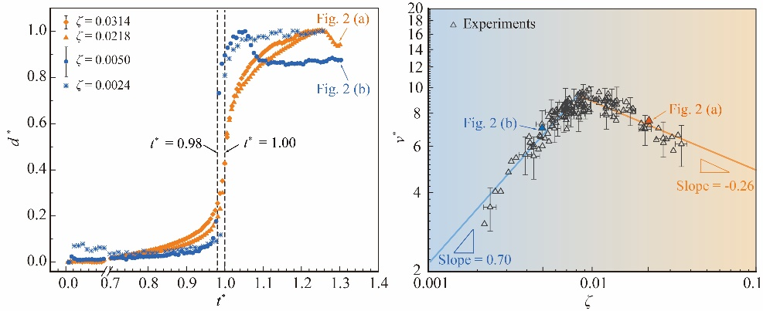
Figure 4. (a) The dependence of dimensionless jet velocity v* on ζ and (b) the characteristics of the dimensionless displacement of the bubble center with different ζ .
- Conclusions
We find by experiments that the jet direction under the combined effect of gravity and vertical rigid boundary can be predicted by the ratio of the dimensionless Kelvin impulse ζ_{g}/ζ_{w}, which corresponds to the influence of gravity and the rigid wall respectively. A distinctive non-monotonic dependence of the dimensionless jet velocity v* on the combined factor ζ =(ζ_{g}²+ζ_{w}²)^{0.5} is revealed. We prove that by choosing the normalized displacement of the bubble center during its final collapse as the characteristic length r∗, the scaling law between v* and ζ can be well predicted by reviewing the integrated momentum variation across the bubble surface.
Acknowledgments
We acknowledge the inspiring discussions with C Sun and M Farhat. We acknowledge financial support from the National Natural Science Foundation of China (Nos. 52076120, 52079066), the State Key Laboratory of Hydroscience and Engineering (2019-KY-04, sklhse-2020-E-03, sklhse-2020-E-05), the Creative Seed Fund of Shanxi Research Institute for Clean Energy, Tsinghua University, and the R&D Program of Beijing Municipal Education Commission (No. KM202211417011).
References
[1] D. Obreschkow, M. Tinguely, N. Dorsaz, P. Kobel, A. de Bosset, and M. Farhat, Universal scaling law for jets of collapsing bubbles, Phys. Rev. Lett. 107, 204501 (2011)
[2] A. M. Zhang, P. Cui, J. Cui, and Q. X. Wang, Experimental study on bubble dynamics subject to buoyancy, J. Fluid Mech. 776, 137 (2015)
[3] A. de Bosset, D. Obreschkow, P. Kobel, N, Dorsaz, and M. Farhat, Direct effects of gravity on cavitation bubble collapse, In 58th International Astronautical Congress IAC (2007)
[4] O. Supponen, D. Obreschkow, M. Tinguely, P. Kobel, N. Dorsaz, and M. Farhat, Scaling laws for jets of single cavitation bubbles, J. Fluid Mech. 802, 263–293 (2016)
[5] J. R. Blake, The Kelvin impulse: Application to cavitation bubble dynamics, The ANZIAM J. 30, 127 (1988)
[6] J. R. Blake, D. M. Leppinen, and Q. X. Wang, Cavitation and bubble dynamics: The Kelvin impulse and its applications, Interface Focus 5, 20150017 (2015)

