Polyoxymethylene dimethyl ether property prediction with a predictive PC-SAFT based methodology
E Geber¹, C Rodriguez¹, I K Karathanassis¹ and M Gavaises¹
¹School of Science & Technology, City, University of London, Northampton Square, EC1V 0HB London, UK

Abstract. A predictive thermodynamic model is utilized for the calculation of fuel properties of polyoxymethylene dimethyl ethers (OME₃₋₄). The model is based on the Perturbed-Chain Statistical Association Fluid Theory (PC-SAFT) equation of state (EoS) and Vapor Liquid Equilibrium (VLE) calculations at constant temperature, density and composition. The pure-component parameters are estimated based on the Group Contribution (GC) method of various sources, as well as a parametrization model specifically designed for the case of OME₃₋₄. The results of the computational model for the density at various conditions, including High Pressure/High Temperature (HPHT), are compared to other computational results available in the literature. Overall, the results are in good agreement with the data from the literature, with the average deviation not exceeding 10%. The use of a specialized pure component parameter estimation technique can further improve the prediction quality, leading to an average deviation of 1%. These results demonstrate the predictive capabilities of the model, which can be extend to a wide range of fuel types and pressure/temperature conditions.

Introduction
While electrification is often proposed as a solution to reduce CO₂ emissions from passenger cars, it seems unlikely that this can be the case for heavy-duty, marine and aviation powertrains. In this applications, alternative fuels like polyoxymethylene dimethyl ethers and other oxygenated fuels are expected to play an important role [1]. Thus, a detailed understanding and modeling of the relations between the fuel properties can be a key factor in reaching future environmental goals. The entire fuel injection process can be affected by thermodynamic and transport properties, leading to differences in the fuel/air mixing, in-nozzle cavitation, engine performance and emission levels [3], [4], [11], [12].
The current study focuses on the calculation of saturation density of OME₃ and OME₄ for a wide range of temperature, including HPHT conditions. The computational model is based on the PC-SAFT EoS [2], which has been proven to be capable of calculating thermodynamic properties of pure substances and mixtures [2]–[6]. Previous work from the authors’ group [7]–[11] has already demonstrated the capabilities of the PC-SAFT EoS [2], as thermodynamic closure in computational fluid dynamics solvers, predicting the in-nozzle flow and subsequent spray development over a wide range of injection and ambient conditions. In another study, properties of multi-component diesel fuel surrogates have been estimated with sufficient precision [12] even under HPHT conditions and by exclusively using GC method estimations for the input parameters. A similar approach is applied in this work, comparing different methods for the estimation of the PC-SAFT input parameters and comparing to computational results from the literature, with the goal of further demonstrating the predictive capabilities of the model for oxygenated fuels.

Numerical Method
The PC-SAFT EoS is a theoretically derived model, based on perturbation theory [2]. It relies on the calculation of the Helmholtz free energy, which in turn is derived as the sum of the hard chain, dispersion and association contributions shown in equation (1):
 | $${\tilde{a}}_{res}={\tilde{a}}_{hc}+{\tilde{a}}_{disp}+{\tilde{a}}_{assoc}$$ | (1)

The GC method of Tihic et al. [13] is implemented in this work, for the estimation of the individual component input parameters of the PC-SAFT. The chemical structure of the molecule is divided into simple, first-order groups and more complex, second-order groups and the PC-SAFT input parameters $m, σ$ and $ε/k$ are computed as a function of each group’s contribution. In addition, the model developed by Schappals et al. [14] is also investigated as a possible solution. In this approach, the number of segments $m$ in OME_{n} is assumed to be linearly dependent on the OME chain length $n$ and the parameters $σ$ and $ε/k$ are considered constant. This is a rather simple approach, which has been developed through fitting of experimental vapor pressure and liquid density data. Thus, it serves as a good reference for comparison with the more generic GC method. The vapor-liquid equilibrium calculations are performed at constant temperature, specific volume, composition and are based on an unconstrainted minimization of the Helmholtz free energy. The algorithm was developed and published by Vidal et al. in [8].

Results
A series of computational results are presented for the saturation density of two highly oxygenated fuels OME₃ and OME₄, in Figure 1 (a) and (b). The saturation density is calculated using the GC method of Tihic et al. [13], as well as the parametrization method proposed by Schappals et al. [14]. As expected, the second method leads to a better estimation of the saturation density, as it is designed specifically for the OME chemical family. Nevertheless, even with the method of Tihic et al. [13] the deviation when compared to the Peng-Robinson (PR) EoS calculations of Fechter et al. [15] is about 10% at low temperatures (300K) but decreases substantially above 500K for OME₃, with the density predicted by the PC-SAFT model remaining consistently higher.

(a) | (b)
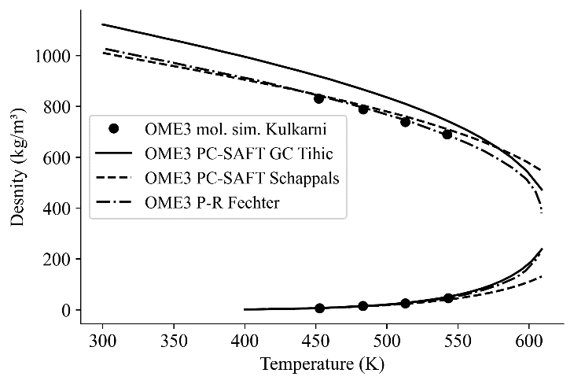 | 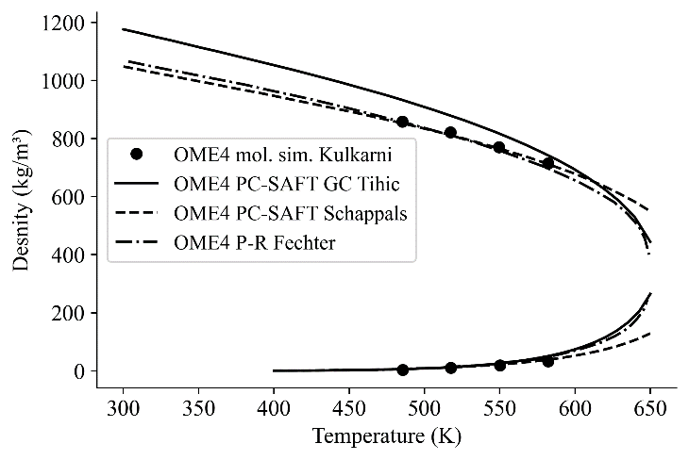
Figure 1. Comparison of PC-SAFT predictions for the saturation density of OME₃ (a) and OME₄ (b) against computational results of Fechter et al. [15] using the PR EoS and the molecular dynamics simulations of Kulkarni et al. [16]. The GC method of Tihic et al. [13] and the parametrization of Schappals et al. [14] were used.

A similar trend is observed in the results for OME₄ in Figure 1 (b), with an error of 10% at low temperatures (300K) for the method of Tihic et al. [13] and a significant decrease of this error above 550K, while the method of Schappals et al. [14] leads to an approximately 10 times smaller deviation. However, it should be noted that around the critical point the method of Schappals et al. [14] is no longer superior, as it starts to produce results with a larger discrepancy compared to the curve of Fechter et al. [15] produced using the PR EoS. The computational results of Fechter et al. [15] are in good agreement with the molecular dynamics simulations of Kulkarni et al. [16], but cover a much larger temperature range. Thus, they are considered a good benchmark for comparison and evaluation of the computational results obtained in this work.

Conclusion
A series of calculations were performed for the saturation density of two oxygenated fuels: OME₃₋₄ up to the critical temperature, using a computational model based on the PC-SAFT EoS. The model’s results were compared against the output of a PR based model and molecular dynamics simulations, published in the literature. The results seem to be in good overall agreement with these data when using GC method proposed by Tihic et al. [13] as well as when the method of Schappals et al. [14] is implemented. The shortcomings of the more generic GC method of Tihic et al. [13] are highlighted, while its superior performance near the critical temperature is also pointed out. Overall, this study successfully applies a purely predictive PC-SAFT based thermodynamic model to OME₃₋₄, showcasing the capabilities of this approach in fuel property calculation. The model could be applied to a wider range of fuels, including multicomponent gasoline or diesel mixtures with alcohols, biodiesel and other promising alternative fuels.

References
[1] T. Verger, U. Azimov, and O. Adeniyi, “Biomass-based fuel blends as an alternative for the future heavy-duty transport: A review,” Renewable and Sustainable Energy Reviews, vol. 161. Elsevier Ltd, Jun. 01, 2022
[2] J. Gross and G. Sadowski, “Perturbed-Chain SAFT : An Equation of State Based on a Perturbation Theory for Chain Molecules,” Ind. Eng. Chem. Res., vol. 40, pp. 1244–1260, 2001
[3] A. Tihic, G. M. Kontogeorgis, N. von Solms, and M. L. Michelsen, “Applications of the simplified perturbed-chain SAFT equation of state using an extended parameter table,” Fluid Phase Equilibria, vol. 248, no. 1, pp. 29–43, Oct. 2006
[4] F. Tumakaka and G. Sadowski, “Application of the Perturbed-Chain SAFT equation of state to polar systems,” Fluid Phase Equilibria, vol. 217, no. 2, pp. 233–239, Mar. 2004
[5] F. Tumakaka, J. Gross, and G. Sadowski, “Thermodynamic modeling of complex systems using PC- SAFT,” Fluid Phase Equilibria, vol. 228–229, pp. 89–98, Feb. 2005
[6] S. Leekumjorn and K. Krejbjerg, “Phase behavior of reservoir fluids: Comparisons of PC-SAFT and cubic EOS simulations,” Fluid Phase Equilibria, vol. 359, pp. 17–23, Dec. 2013
[7] P. Koukouvinis, C. Rodriguez, J. Hwang, I. Karathanassis, M. Gavaises, and L. Pickett, “Machine Learning and transcritical sprays: A demonstration study of their potential in ECN Spray-A,” International Journal of Engine Research, vol. 23, no. 9, pp. 1556–1572, Sep. 2022
[8] A. Vidal, P. Koukouvinis, and M. Gavaises, “Vapor-liquid equilibrium calculations at specified composition, density and temperature with the perturbed chain statistical associating fluid theory (PC-SAFT) equation of state,” Fluid Phase Equilibria, vol. 521, Oct. 2020
[9] P. Koukouvinis, A. Vidal-Roncero, C. Rodriguez, M. Gavaises, and L. Pickett, “Enhancing the predictive capabilities for high P/T fuel sprays; non-ideal thermodynamic modelling using PC- SAFT,” Nov. 2020, [Online]. Available: http://arxiv.org/abs/2011.09983
[10] A. Vidal, K. Kolovos, M. R. Gold, R. J. Pearson, P. Koukouvinis, and M. Gavaises, “Preferential cavitation and friction-induced heating of multi-component Diesel fuel surrogates up to 450MPa,” Int. J. Heat Mass Transf., vol. 166, Feb. 2021
[11] C. Rodriguez, P. Koukouvinis, and M. Gavaises, “Simulation of supercritical diesel jets using the PC- SAFT EoS,” Journal of Supercritical Fluids, vol. 145, no. November 2018, pp. 48–65, 2019
[12] A. Vidal, C. Rodriguez, P. Koukouvinis, M. Gavaises, and M. A. McHugh, “Modelling of Diesel fuel properties through its surrogates using Perturbed-Chain, Statistical Associating Fluid Theory,” International Journal of Engine Research, vol. 21, no. 7, pp. 1118–1133, Sep. 2020
[13] A. Tihic, G. M. Kontogeorgis, N. Von Solms, and M. L. Michelsen, “A predictive group-contribution simplified PC-SAFT equation of state: Application to polymer systems,” Ind. Eng. Chem. Res., vol. 47, no. 15, pp. 5092–5101, Aug. 2008
[14] M. Schappals, T. Breug-Nissen, K. Langenbach, J. Burger, and H. Hasse, “Solubility of Carbon Dioxide in Poly(oxymethylene) Dimethyl Ethers,” J. Chem. Eng. Data., vol. 62, no. 11, pp. 4027– 4031, Nov. 2017
[15] M. H. H. Fechter, P. Haspel, C. Hasse, and A. S. Braeuer, “Vapor pressures and latent heats of vaporization of Poly(oxymethylene) Dimethyl Ethers (OME3 and OME4) up to the vicinity of the critical temperature,” Fuel, vol. 303, Nov. 2021
[16] A. Kulkarni et al., “A Force Field for Poly(oxymethylene) Dimethyl Ethers (OMEn),” J. Chem. Theory Comput., vol. 16, no. 4, pp. 2517–2528, Apr. 2020

