Impact of Needle Tip Geometry on Pilot Diesel Injection
¹Marilia G. Justino Vaz*; ¹Ioannis Karathanasis, ¹Manolis Gavaises,
School of Mathematics, Computer Science and Engineering, CITY, University of London, UK;

Abstract..The needle tip geometry at low needle lift plays an important role on in-nozzle flow morphology and dynamics. Therefore, their optimization is relevant to improve the fuel mixture formation characteristic for Dual-Fuel Internal Combustion Engines and fitting the strict emissions legislation. This work focuses on the comparison of three proposed needle tip geometries to a base industrial design. Those comparisons are carried out via numerical simulations, where the variation of the physical and transport properties of the liquid fuel is done via Perturbed Chain Statistical Associating Fluid Theory equation of state. The results showed good prediction capabilities with a reasonable computation cost and one of the proposed designs attenuate the cavitation inside the spray holes in contrast to the base one.

Introduction
The substitution of the conventional Diesel engine for Dual-Fuel (DF) operation is a short-term answer for strict emission legislations[1]. In DF strategy, the primary fuel with a high-octane number provides most of the energy power and designs the combustion characteristics [2]. The secondary one, usually Diesel in small amount, acts as an ignition source,also named as pilot injection [3]. Conversely, even not being a new technology, DF combustion engines still raises important questions due to the heterogeneous character of the entire process [4].

Currently diesel engines use high-pressure injection systems, operating around 200MPa, and can even reach 300MPa [5]. This high injection pressure in association to sharp geometric changes in the nozzle design impose significant variations in the fuel distribution properties due to high fuel velocities, local depressurization and pressure gradients [6], where those effects may be more pronounced in low needle lift positions. Those factors impose challenges regarding the reproduction of the injection process via numerical simulations [7]. This initial study aims to understand the needle tip geometry effects during pilot injection where the needle lift is minimal opened, since it plays a major role in in-nozzle flow morphology and dynamics. In addition, a methodology for spray modelling is proposed, including in the solver the Perturbed Chain Statistical Associating Fluid Theory (PC-SAFT) equation of state (EoS) via Tabulation [8].

Numerical Method
In this work a multi-fluid model is applied to the three components existing in Diesel injection: liquid fuel, fuel vapor and ambient gas (nitrogen). The fuel and ambient gas are treated as homogeneous mixture under mechanical and thermal equilibrium [9]. As a consequence, all phases and components share the same velocity, pressure and temperature fields in each computational cell. In addition, a diffuse interface approximation is assumed at the liquid-air interface. Following the multi-fluid approach, four partial differential equations are solved in conjunction to the thermodynamic closure: mass conservation, momentum, transport and energy. Those equations are solved iteratively with a pressure-based solver using the Pressure-Velocity Coupled algorithm. In addition, the commercial software ANSYS Fluent© is supplemented with external user-defined functions [10] to incorporate the variation of the physical and transport properties of the liquid fuel via PC-SAFT. Furthermore, in order to reduce to computational cost realted to EoS calculations, the thermodynamic and transport properties of the fuel

were calculated prior to the CFD simulations and stored in structured tables, decoupling the evaluation during flow calculation and, thus, speeding-up the simulation [11].

Results
The current study examines the impact of the needle tip geometry in an industrial injector design provided by Woodward L’Orange. The base design (needle tip 01) consists of a 7 holes Diesel injector with 0 conicity and 319𝜇𝑚 spray hole diameter and was compared with three proposed ones, named: needle tip 02, needle tip 03 and needle tip 04. In order to save computational resources, only one hole is modelled (1/7 sector). The computational domain consists of different surfaces: needle, housing, inlet, side surfaces and outlet. The outlet is a 1.5mm long conical volume and the needle was placed at 54𝜇𝑚, the minimal lift measured for injection. In all simulations, a pressure boundary condition of 1600bar was applied to the inlet of the domain. The 𝑛-dodecane at 343k was chosen for the fuel entering the domain without taking into account the non-condensable gas in the fuel. A symmetry boundary condition has been applied to the side surfaces and fixed pressure outlet was applied to the outlet surfaces, with pressure 50bar and temperature 780K and nitrogen volume fraction prescribed as 1 in the case of back-flow. The four needle tip geometries are illustrated in Figure 1. At low needle lift, the fuel is under higher deflection and consequently higher acceleration. In the entrance of the spray hole, the base design (needle tip 01) enhances cavitation, where the n-dodecane vapor is mainly located in the upper part along the spray hole and induces a higher amount of vapor. Needle tip 03 follows the same behaviour with a slight reduction of the vapor volume. The proposed geometries needle tip 02 and 04 soften the cavitation intensity, reducing the n-dodecane vapor formed inside the injector considerably compared to the base design (needle tip 01). Furthermore, needle tip 02 relocates the low pressure region mainly inside the sac hole instead of the spray hole as illustrated in the others geometries.
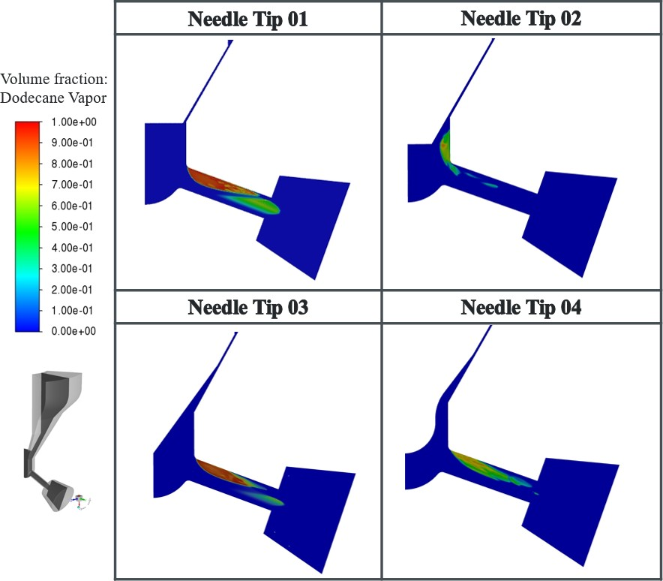
Figure 1 𝑛-dodecane vapor volume fraction at the plane perpendicular to the orifice for the four needle geometries tip at 54𝜇𝑚 needle lift (pilot injection configuration)

Conclusions
The fuel properties predicted via PC-SAFT EoS were incorporated on the commercial software ANSYS Fluent© via tabulated thermodynamic approach. Then, this methodology was applied in an industrial injector design to predict the in-nozzle flow and understand the impact of the needle tip geometry at Diesel pilot injection conditions. Starting from a base design, three geometries were proposed in order to mitigate the vapour formation inside the spray hole. Those geometries were qualitative compared at 54𝜇𝑚 needle lift, where needle tip 02 presents the best performance to attenuate the cavitation inside the spray hole.

Acknowledgments
This work has received funding from the European Union’s Horizon 2020 research and innovation programme under the Marie Sklodowska-Curie grant agreement No 861002

References
- P. Fasching, F. Sprenger, and C. Granitz, 2019 A holistic investigation of natural gas–diesel dual fuel combustion with dual direct injection for passenger car applications In: Automotive and Engine Technology 2.16 pp. 79–95. doi: 10.1007/s41104-017-0018-4
- Mohamed El Hannach et al. 2019 Life cycle assessment of hydrogen and diesel dual-fuel class 8 heavy duty trucks In: International Journal of Hydrogen Energy 44.16 pp. 8575– 8584. doi: 10.1016/j.ijhydene.2019.02.027.
- Federal Ministry of Transport and Digital Infrastructure. LNG as an alternative fuel for the operation of ships and heavy-duty vehicles. The Herries Press. 2014.
- Peng Geng et al. 2019 Effects of alternative fuels on the combustion characteristics and emission products from diesel engines: A review In: Renewable and Sustainable Energy Reviews 71
pp. 523–534. doi: /10.1016/j.rser.2016.12.080.
- P. Koukouvinis, A. Vidal, C. Rodriguez and M. Gavaises 2020 Enhancing the predictive capabilities for high P/T fuel sprays; non-ideal thermodynamic modelling using PC-SAFT ERCOFTAC Bulletin, no. 89
- A. Vidal, K. Kolovos, M. Gold and R. Pearson 2021 Preferential cavitation and friction-induced heating of multi-component Diesel fuel surrogates up to 450MPa International Journal of Heat and Mass Transfer, vol. 166, 2021.
- P. Kundu, C. Xu, S. Som, J. Temme, C. Kweon, S. Lapointe, G. Kukkadapu and W. Pitz 2021 Implementation of multi-component diesel fuel surrogates and chemical kinetic mechanisms for engine combustion simulations Transportation Engineering, 35.
- Gross, J. and Sadowski, G. 2001 Perturbed-chain SAFT:An equation of state based on a perturbation theory for chain molecules Industrial & Engineering Chemistry Research, vol. 40, no. 4, pp. 1244-1260
- A. Prosperetti and G. Tryggvason, 2009 Computational Methods for Multiphase Flow.
Cambridge University Press
- Inc., 2018 ANSYS Fluent v19.1 Manual
- A. Rubino, M. Pini, M. Kosec, S. Vitale and P. Coluna 2018 A look-up table method based on unstructured grids and its application to non-ideal compressible fluid dynamic simulations Journal of Computational Science, vol. 28, pp. 70-77

*Corresponding Author, Marilia G. Justino Vaz Marilia.Justino-Vaz@city.ac.uk

