Scale Resolving Simulation of High Pressure Liquid Injection Process
¹Marija Stipic*; ¹Branislav Basara; ²Steffen Schmidt; ²Nikolaus Adams
¹Advance Simulation Technology CDF, AVL GmbH, Austria
²Institute for Aerodynamics and Fluid Mechanics, Technical University of Munich, Germany
Abstract. In this work widely used Lagrangian Discrete Droplet Method (DDM) for spray modelling has been coupled with Partially-Averaged Navier-Stokes (PANS) turbulence model to simulate well established ECN Spray A test case. Both, reactive and non-reactive simulation cases are shown. For the reactive simulation Flamelet Generated Manifold tabulated chemistry approach was employed. The liquid length and vapor penetration obtained from CFD simulation are compatible with the experimental measurements and thus capability of the DDN/PANS numerical approach to address spray conditions with high relevance to Diesel engines is demonstrated. The results showed that the PANS model can accurately capture unsteady flow features.
Keywords: Spray modelling, Partially Averaged Navier Stokes, Tabulated chemistry
Introduction
For numerous combustion systems determination of combustion characteristics and consequently formation of emissions depends heavily on fuel atomization and spray breakup processes. As the demand for improved fuel efficiency and reduced emissions continues to grow, it becomes increasingly necessary to gain a fundamental understanding of this process. Fuel injection process involves many physical processes such as in-nozzle cavitation, liquid atomization, phase change, mixing and chemical reactions which are followed by variety of length and time scales. Consequently, numerical modelling of fuel injection is a challenging task. Several modelling approaches with varying complexity have been formulated to address this problem. The most common method for numerical modeling of spray process for engineering calculations is based on the Discrete Droplet Model (DDM) where the liquid phase is described by Lagrangian particles, while the gas phase is modeled in Eulerian framework [1]. Despite various shortcoming, such as high sensitivity to mesh resolution in the near nozzle resolution, this method has proven it efficiency and sufficient accuracy to describe spray dynamics in the industrial development process. In the work of [2]–[5], DDM approach is coupled with Large Eddy Simulation (LES) approach for turbulence modelling, with an aim to consider the atomized Lagrangian fuel droplets which lie in the subgrid range as well as their interactions with surrounding carrier phase. To avoid extreme computational cost associated with LES modelling approach in this work, DDM approach is coupled with Partially-Averaged Navier-Stokes k-𝜁-f [6] turbulence model. By resolving a portion of the large, unsteady flow motion this model provides improved results over RANS method with significantly lower computational effort than needed for LES. In this work, the ECN Spray A is used to test performance of DDM/PANS numerical approach to depict high-pressure fuel injection with conditions relevant to Diesel engines.
Numerical Method
Detailed description of ECN Spray A experiment can be found in [7]. In this test case, a liquid n- dodecane is injected through a nozzle hole of diameter 𝑑 = 90𝜇𝑚 at high injection pressure (150 MPa) into ambient gas of temperature T=900K. The AVL FIRETM 3D-CFD solver based on the finite volume approach, has been adopted in this study to perform reactive and non-reactive simulations of Spray A test case. Spray model is based on Lagrangian Discrete Droplet Method, in which a sample of individual droplets similar in size and physical properties are grouped together into parcels and tracked along with continuous gas phase throughout the simulation domain. The Partially Averaged Navier Stokes turbulence model used in this study, falls in the category of hybrid RANS/LES turbulence models, purported to smoothly vary between RANS and DNS, based on the model resolution parameters. In this study the PANS variant derived from RANS k-𝜁-f model with additional scale supplying equation (SSV) is employed. SSV equation determines resolved turbulent kinetic energy thus supplying the
information for the correct cut-off scale. Detailed description of the PANS k-𝜁-f SSV model can be found in [6]. The level of the physical resolution depends entirely upon model resolution parameters, unresolved-to-total turbulent kinetic energy ($f_{k}$) and eddy dissipation ($f_{ε}$) ratios. As $f_{k}$ and $f_{ε}$ tend to unity, PANS equations reduce to RANS. When resolution parameters equal to zero a direct numerical simulation is performed. One of the most important unclosed terms in PANS model is turbulent transport of unresolved kinetic energy and dissipation [8]. Development of turbulent transport models for unresolved quantities is presented in [8]. In this work the maximum transport model is adopted. For the species transport and combustion modelling in case of a reactive simulation, the Flamelet Generated Manifold (FGM) tabulated chemistry was employed. The FGM lookup table was generated from Hybrid reduced n-dodecane chemical mechanism [9] with 65 species and 363 reactions. To account for turbulent chemistry interactions the 𝛽-PDF-averaging of the lookup table over mixture fraction is performed. Computational mesh is generated as cubic hexahedral grid structure where the base grid cell size is 1mm located at the outer edge of the domain while multiple mesh refinement levels have been employed to achieve minimum cell size of 62.5𝜇𝑚 in the near nozzle exit region.
Results
In the case of non-reactive simulation, comparison in terms of liquid length and vapor penetration between the CFD results employing DDM/PANS approach and experimental data is shown in the Figure 1. As visible from the figure, both liquid and vapor penetration obtained from the simulation are in good agreement with the experiment.
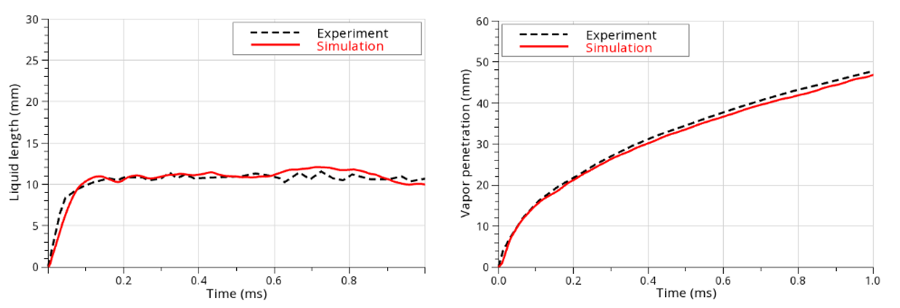
Figure 1. Liquid and vapor penetration obtained from DDM/PANS simulation compared to measurement.
Figure 2 shows temperature and equivalence ratio distribution as obtained by DDM/PANS numerical approach from reactive spray simulation. As can be seen from the obtained results, employing PANS turbulence modeling approach results in capturing many of unsteady flow features. In the Figure 3 model resolution parameter, total, unresolved and resolved turbulence kinetic energy are shown. Maximum value of the resolution parameter lies in the region close to the nozzle exit which can’t be resolved by the mesh of this resolution. In this region, RANS equations are recovered hence adequate description of the dense spray region is preserved despite insufficient mesh resolution for resolved simulation in this region. Comparing the results, it can be observed that maximum unresolved energy is in the region where $f_{k}$ is unity. Contrary, maximum of the resolved energy is where $f_{k}$ has lower values. Summing up the unresolved and resolved energy total turbulent kinetic energy is obtained.
Conclusion
In this work potential of Lagrangian Discrete Particle method coupled PANS k-𝜁-f SSV turbulence model to simulate non-evaporating and evaporating sprays in conditions relevant to Diesel engines is shown. The physics of the studied case, ECN Spray A, was accurately captured and results in terms of liquid length and vapor penetration are in good agreement with experiment. Employing PANS turbulence approach showed possibility of capturing large scale fluctuations of the turbulent flow without a burden of having to resolve inertial scales.
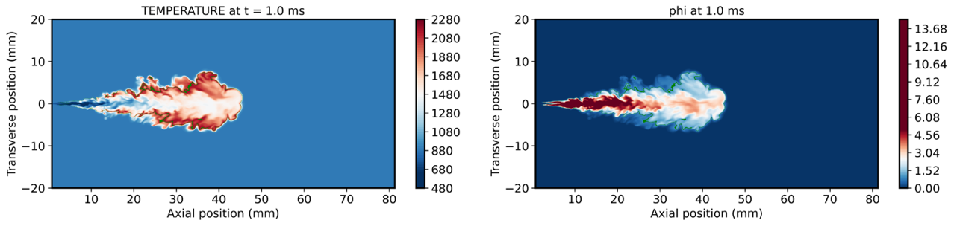
Figure 2. Temperature and equivalence ratio distribution as obtained by DDM/PANS simulation.
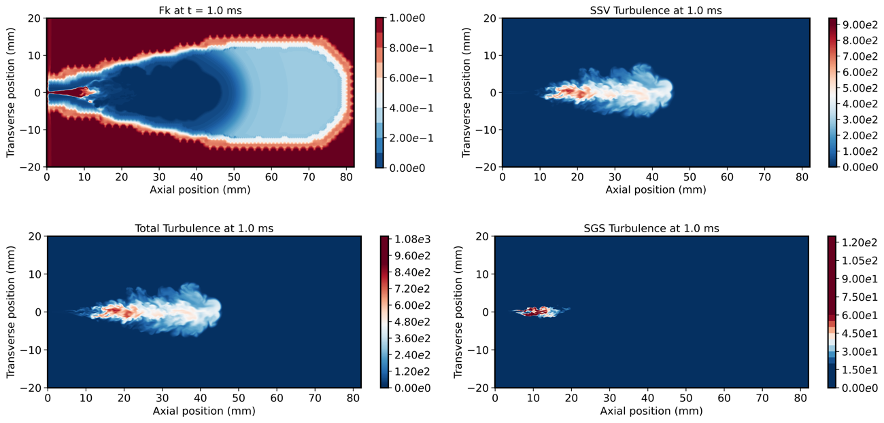
Figure 3. Resolution parameter (upper left), total (lower left), resolved (upper right) and unresolved (lower right) turbulence kinetic energy as obtained by DDM/PANS numerical approach.
References
[1] H. Gaballa, C. Habchi, and J.-C. de Hemptinne, “Modeling and LES of high-pressure liquid injection under evaporating and non-evaporating conditions by a real fluid model and surface density approach,” International Journal of Multiphase Flow, vol. 160, p. 104372, Mar. 2023, doi: 10.1016/j.ijmultiphaseflow.2022.104372.
[2] C. Rutland, “LES Modeling for IC Engines.”
[3] N. Bharadwaj, C. J. Rutland, and S. Chang, “Large eddy simulation modelling of spray-induced turbulence effects,” International Journal of Engine Research, vol. 10, no. 2, pp. 97–119, Apr. 2009, doi: 10.1243/14680874JER02309.
[4] O. T. Kaario, V. Vuorinen, H. Kahila, H. G. Im, and M. Larmi, “The effect of fuel on high velocity evaporating fuel sprays: Large-Eddy simulation of Spray A with various fuels,” International Journal of Engine Research, vol. 21, no. 1, pp. 26–42, Jan. 2020, doi: 10.1177/1468087419854235.
[5] M. Sanjosé, J. M. Senoner, F. Jaegle, B. Cuenot, S. Moreau, and T. Poinsot, “Fuel injection model for Euler–Euler and Euler–Lagrange large-eddy simulations of an evaporating spray inside an aeronautical combustor,” International Journal of Multiphase Flow, vol. 37, no. 5, pp. 514–529, Jun. 2011, doi: 10.1016/j.ijmultiphaseflow.2011.01.008.
[6] B. Basara, Z. Pavlovic, and S. Girimaji, “A new approach for the calculation of the cut-off resolution parameter in bridging methods for turbulent flow simulation,” Int J Heat Fluid Flow, vol. 74, pp. 76–88, Dec. 2018, doi: 10.1016/j.ijheatfluidflow.2018.09.011.
[7] L. M. Pickett and G. Bruneaux, “Engine Combustion Network.”
[8] Aditya Murthi, Dasia A. Reyes, Sharath S. Girimaji, and Branislav Basara, “Turbulent transport modelling for PANS and other bridging closure approaches,” in Proceedings of the V European Conference on Computational Fluid Dynamics ECCOMAS CFD 2010, Lisbon, Jul. 2010.
[9] “Lawrence Livermore National Laboratory,” http://combustion.llnl.gov/.

