Cavitation erosion assessment of a wobbling high-pressure fuel injector
¹M. Ozgunoglu*; ¹M. Arabnejad; ²G. Mouokoue; ^{1,3}M. Oevermann; ¹R. Bensow
¹Chalmers University of Technology, Gothenburg, SW
²Woodward L’Orange, Stuttgart, DE
³Brandenburg University of Technology Cottbus-Senftenberg, Cottbus, DE
Abstract
This study investigates cavitation induced erosion due to 3-axis needle motion inside a high-pressure fuel injector. The flow inside the high-pressure fuel injectors is prone to low-pressure regions where cavitation is triggered once the pressure drops below the vapor pressure. Repetitive violent collapse events of vapor structures can finally alter the geometry via material loss. This cavitation induced erosion affects the performance of the injectors and may lead to operating failures [1].
There are previous studies investigating different types of dynamic mesh motion approaches such as cartesian cut-cell [2], node interpolation [3] and Arbitrary Lagrangian–Eulerian [4] methods. To the best of our knowledge, there is no study that applies the overset mesh methodology and examines cavitation erosion for wobbling needle motion. Despite the time cost for mesh and topology construction, overset mesh technique is a promising approach as it allows to simulate very low needle positions with non-skewed cells unlike the aforementioned approaches.
As a first step, a Woodward L’Orange injector is investigated in static high lift (480μm) condition. The studied model and a 3D experimental mold taken at the end of the experiment is shown in Figure 1.For the mold, the geometry is filled with an epoxy material, which fills gaps of the eroded material. The flow is examined with the help of unsteady Reynolds Averaged Navier Stokes simulation. Assuming a homogeneous mixture, cavitation is modelled via the mass transfer approach. Hence, the Zwart-Gerber-Belamri cavitation modelling is used with altered model coefficients.
Cavitation erosion is assessed with a combined approach [5,6] using different post processing erosion indicators. Figure 2 shows surface plots of the maximum squared material derivative of pressure, ${{(DP}/{Dt})}^{2}$, evaluated throughout the simulated time. Maximum values appear only on the upper surface of the orifice in accordance with the experiment.
Further analysis will include needle lift and off-axis motion effects utilizing the overset mesh methodology.
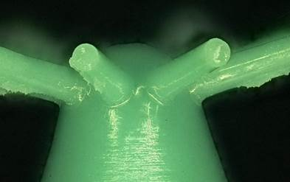
Figure 1: 8-hole Woodward L'Orange injector model in high lift condition (left), experiment (right)
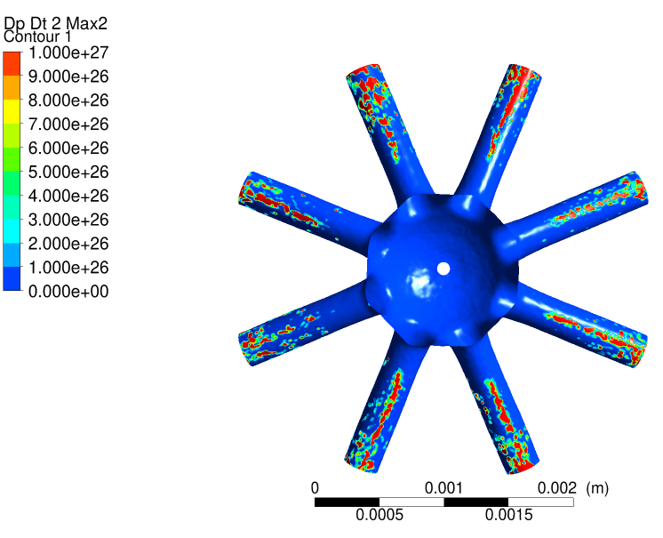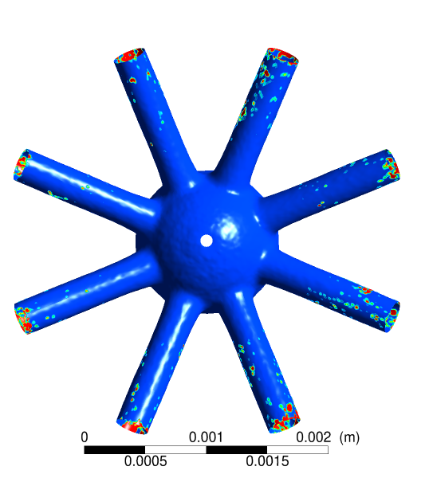
Figure 2: Maximum squared material derivative of pressure, ${{(DP}/{Dt})}^{2}$, throughout the simulated time. Top (left) and bottom (right) of the injector.

References
[1] Osman, A. 2006. “Failure of a Diesel Engine Injector Nozzle by Cavitation Damage.” Engineering Failure Analysis 6: 1126-33
[2] Xue, Q., Som, S., Battistoni, M., Longman, D. E., Zhao, H., Senecal, P. K., & Pomraning, E. (2013). Three-Dimensional Simulations of the Transient Internal Flow in a Diesel Injector: Effects of Needle Movement. ILASS Americas, May.
[3] Gomez Santos, E., Shi, J., Venkatasubramanian, R., Hoffmann, G., Gavaises, M., & Bauer, W. (2021). Modelling and prediction of cavitation erosion in GDi injectors operated with E100 fuel. Fuel, 289, 119923.
[4] ﻿Kolovos, K., Kyriazis, N., Koukouvinis, P., Vidal, A., Gavaises, M., & McDavid, R. M. (2021). Simulation of transient effects in a fuel injector nozzle using real-fluid thermodynamic closure. Applications in Energy and Combustion Science, 7, 100037.
[5] ﻿Mouvanal, S., Chatterjee, D., Bakshi, S., Burkhardt, A., & Mohr, V. (2018). Numerical prediction of potential cavitation erosion in fuel injectors. International Journal of Multiphase Flow, 104, 113–124.
[6] Brunhart, M. (2020). Cavitation and the application of methods for erosion prediction in high pressure fuel injection systems.

